A Project Report

on

Crowd Monitoring System

carried out as part of the Minor Project IT3270 Submitted

by

<Ayushman Saxena>
<209302148>

<Prajwal Bang>
< 209303238 >

in partial fulfilment for the award of the degree of

Bachelor of Technology

in

Information Technology

Under the Guidance of
Guide Name



School of Information Technology
Department of Information Technology

MANIPAL UNIVERSITY JAIPUR
RAJASTHAN, INDIA

April 2023

CERTIFICATE

Date: 21.04.2023

This is to certify that the minor project titled <Crowd Monitoring System> is a record of the bonafide work done by Ayushman Saxena (209302148) and Prajwal Bang (209303238) submitted in partial fulfilment of the requirements for the award of the Degree of Bachelor of Technology in Information Technology of Manipal University Jaipur, during the academic year 2022-23.

<Deevesh Choudhary>
< Assistant Professor>

Project Guide, Department of Information Technology

Manipal University Jaipur

Dr. Pankaj Vyas

HoD, Department of Information Technology
Manipal University Jaipur

ABSTRACT

Crowd monitoring is a critical element in ensuring public safety during large-scale events or gatherings. Traditional crowd monitoring techniques, such as manual counting or observation, are time-consuming and prone to errors. To address these challenges, this project aims to develop an automated crowd monitoring system using computer vision techniques. The system will use live camera feeds and machine learning algorithms to analyze video data in real-time, detect and track crowd movement, density, and behavior, and generate alerts for potential crowd safety risks. The project will explore various deep learning models, such as CNNs and RNNs, to develop accurate and robust crowd detection and tracking algorithms. The proposed system has the potential to improve situational awareness and enhance public safety during crowded events and can be used by event organizers, law enforcement agencies, and emergency services.

The proposed system will comprise several stages, including video input, preprocessing, object detection, object tracking, and output analysis. The system's input will be live camera feeds from multiple angles, which will be preprocessed to remove noise and enhance image quality. The object detection stage will identify human objects in the video stream, and the object tracking stage will track their movements over time. The system will use the output from these stages to analyze crowd patterns and generate alerts for potential safety risks. The system's output will be in the form of visualizations, such as heatmaps and trajectory plots, which will provide situational awareness for event organizers and public safety officials. The project's success will be evaluated based on the system's accuracy, speed, and effectiveness in detecting and tracking crowds and generating alerts for safety risks.

Table of Contents

1. Introduction 5-7

    - Introduction
    - Problem Statement
    - Objectives
    - Scope of Project

2. Objectives 7

2.1 Literature Review
2.2 Other Software Engineering Methodologies

3. System Design & Methodology 8

    - System Architecture
    - Development Environment
    - Methodology

4. Implementation and Result 9-10

4.1. Modules in Project
4.2. Implementation Detail
4.3 Results and Discussion
4.2 Month wise plan of work

5. Conclusion and Future Plan 11

6. References 12

Introduction

1.1 Introduction

Overview with Applications: Crowd behavior monitoring refers to the study and analysis of the behavior and movements of individuals in a group or crowd setting. It has a wide range of applications in areas such as crowd control and safety management, traffic management, and urban planning. In this review paper, we will discuss the current state of research on crowd behavior monitoring, focusing on the methods and techniques used for data collection and analysis, and the strengths and limitations of these methods.

Crowd behavior monitoring is an interdisciplinary field that draws from fields such as sociology, psychology, computer science, and engineering. Crowd behavior has been of interest to researchers for many years due to its complex nature and the potential impact it can have on public safety and security. In recent years, advances in technology have enabled more effective methods of crowd behavior monitoring, leading to improved understanding of the behavior of individuals in crowd situations.

A variety of methods and techniques have been used for crowd behavior monitoring, including video and image analysis, computer vision techniques, and sensors such as GPS and accelerometers. Video and image analysis techniques, such as object detection and tracking, have been used to study crowd behavior by tracking the movements of individuals in a crowd. Computer vision techniques, such as machine learning algorithms, have been used to automate the process of tracking and analyzing crowd behavior.

Sensors, such as GPS and accelerometers, have been used to track the movements of individuals in a crowd in real-time. These sensors provide valuable data on the behavior of individuals in a crowd, including their location, speed, and direction of movement. This information can be used to identify potential crowd problems and to develop strategies for crowd management and control.

Motivation: Crowd behavior analysis using machine learning is an important research topic as it can help to better understand the dynamics of collective behavior in social and crowd settings. Machine learning algorithms can be used to identify patterns and trends in crowd behavior that could not be captured through traditional methods. This research can be used to identify potential risks and optimize crowd management, as well as to gain insight into how people interact, how they form opinions and how they make decisions in a crowd setting. Machine learning algorithms can also be used to detect early signs of crowd unrest and to better understand the factors that could lead to crowd violence. This research can help to improve safety and security in public places and to reduce the potential for crowd-related incidents.

1.2: Problem Statement:

Crowd monitoring to avoid stampedes is a critical issue during crowded events, where large crowds can pose significant safety risks. Stampede incidents can occur suddenly and without warning, leading to injuries or fatalities. The problem is how to develop a crowd monitoring system that can detect early signs of crowd congestion and generate timely alerts to prevent stampedes from occurring. Existing crowd monitoring systems are often limited in their ability to detect subtle changes in crowd behavior, and may not provide real-time updates, making it challenging to respond quickly to potential risks. Therefore, there is a need to develop an advanced crowd monitoring system that incorporates advanced sensors and cameras, coupled with machine learning techniques to analyze data and detect patterns that indicate potential risks.

1.3 Objectives:

1. Avoid Stampedes: Development of a proper warning system to avoid stampedes refers to the creation of a system that can detect the early signs of crowd congestion and generate timely alerts to prevent a stampede from occurring. A stampede is a sudden, uncontrolled rush of people that can occur in a crowded environment, leading to injuries or fatalities. Thus, a warning system to avoid stampedes is essential to ensure public safety during crowded events.

2. Early Detection of Crowding: The primary objective of a crowd monitoring system in avoiding stampedes is to detect the early signs of crowding. By monitoring the density of the crowd and its movement patterns, the system can identify areas of congestion and predict where stampedes may occur.

3. Timely Alert Generation: Once a potential stampede is detected, the system should generate timely alerts to the event organizers and public safety officials. This can help them to take immediate action to alleviate the congestion and prevent a stampede from occurring.

4.Effective Communication: Effective communication is critical during a stampede. A crowd monitoring system should provide event organizers and public safety officials with real-time updates on the crowd's behavior, enabling them to communicate effectively with the attendees and provide guidance on the best course of action.

5.Optimal Resource Allocation: A crowd monitoring system can also help to optimize resource allocation during a stampede. By providing real-time information on the crowd's movements, the system can help event organizers and public safety officials to allocate their resources, such as security personnel or medical staff, more effectively and efficiently.

1.4 Scope of Project:

The project covers early detection of crowding and object detection part of crowd monitoring system along with proper warning system to alert in case crowd formation is taking place. The early detection of crowding involves monitoring the density and movement patterns of crowds.
Object detection is another critical component added to the model. Object detection involves identifying and tracking objects within a scene, such as cars which may contribute to crowd control and animals which can pose a potential security risk . The system can use computer vision techniques to identify these objects and track them as they move through the scene, allowing event organizers and security officials to monitor them closely.

Both the early detection of crowding and object detection are critical components of a crowd monitoring system, and both fall under the scope of a crowd monitoring project. The project scope includes the development of advanced algorithms, and computer vision techniques to enable the system to detect early signs of crowding and identify potential security risks. The scope of the project also includes the development of a warning system that generates timely alerts to event organizers and public safety officials in the event of potential risks. Overall, the aim is to create an effective crowd monitoring system that can ensure public safety during crowded events by detecting early signs of crowding and identifying potential security risks.
Background Detail

1. Conceptual Overview:

Recent studies have explored innovative approaches to crowd monitoring and public safety. One such approach involves applying virtual reality (VR) technology to simulate risky environments and fires for research purposes. Another approach involves utilizing the Internet of Things (IoT) to track pedestrian movements and develop large-scale crowd monitoring systems. Literature identifies five types of digital sensors that can be incorporated into crowd monitoring systems, including camera-based monitoring systems, Bluetooth/Wi-Fi sensors, GPS trackers, mobile phone data, and social media crawlers. These sensors can be used to gather data on pedestrian activity, location choices, and movements at large-scale events, providing valuable insights into crowd behavior and enabling effective crowd management strategies.

The literature also identifies several types of digital sensors that are used in crowd monitoring. One type is camera-based monitoring systems, which use a combination of cameras, minicomputers, and AI or computer vision algorithms to study pedestrian crowd movements. These systems can be enhanced by using multiple overlapping cameras to gather more comprehensive data. Another type of sensor is Wi-Fi and Bluetooth sensors, which track the signals emitted by mobile devices to estimate pedestrian numbers and movements. GPS traces can also be used to study pedestrian movements at public spaces or large-scale events. Additionally, GSM data obtained from mobile networks can be used to capture pedestrian crowd information. Finally, social media platforms can provide information on the crowd itself, including its distribution, age, and country of origin. These sensors offer valuable insights into crowd behavior and can enable effective crowd management strategies.

System Design & Methodology

3.1 System Architecture:

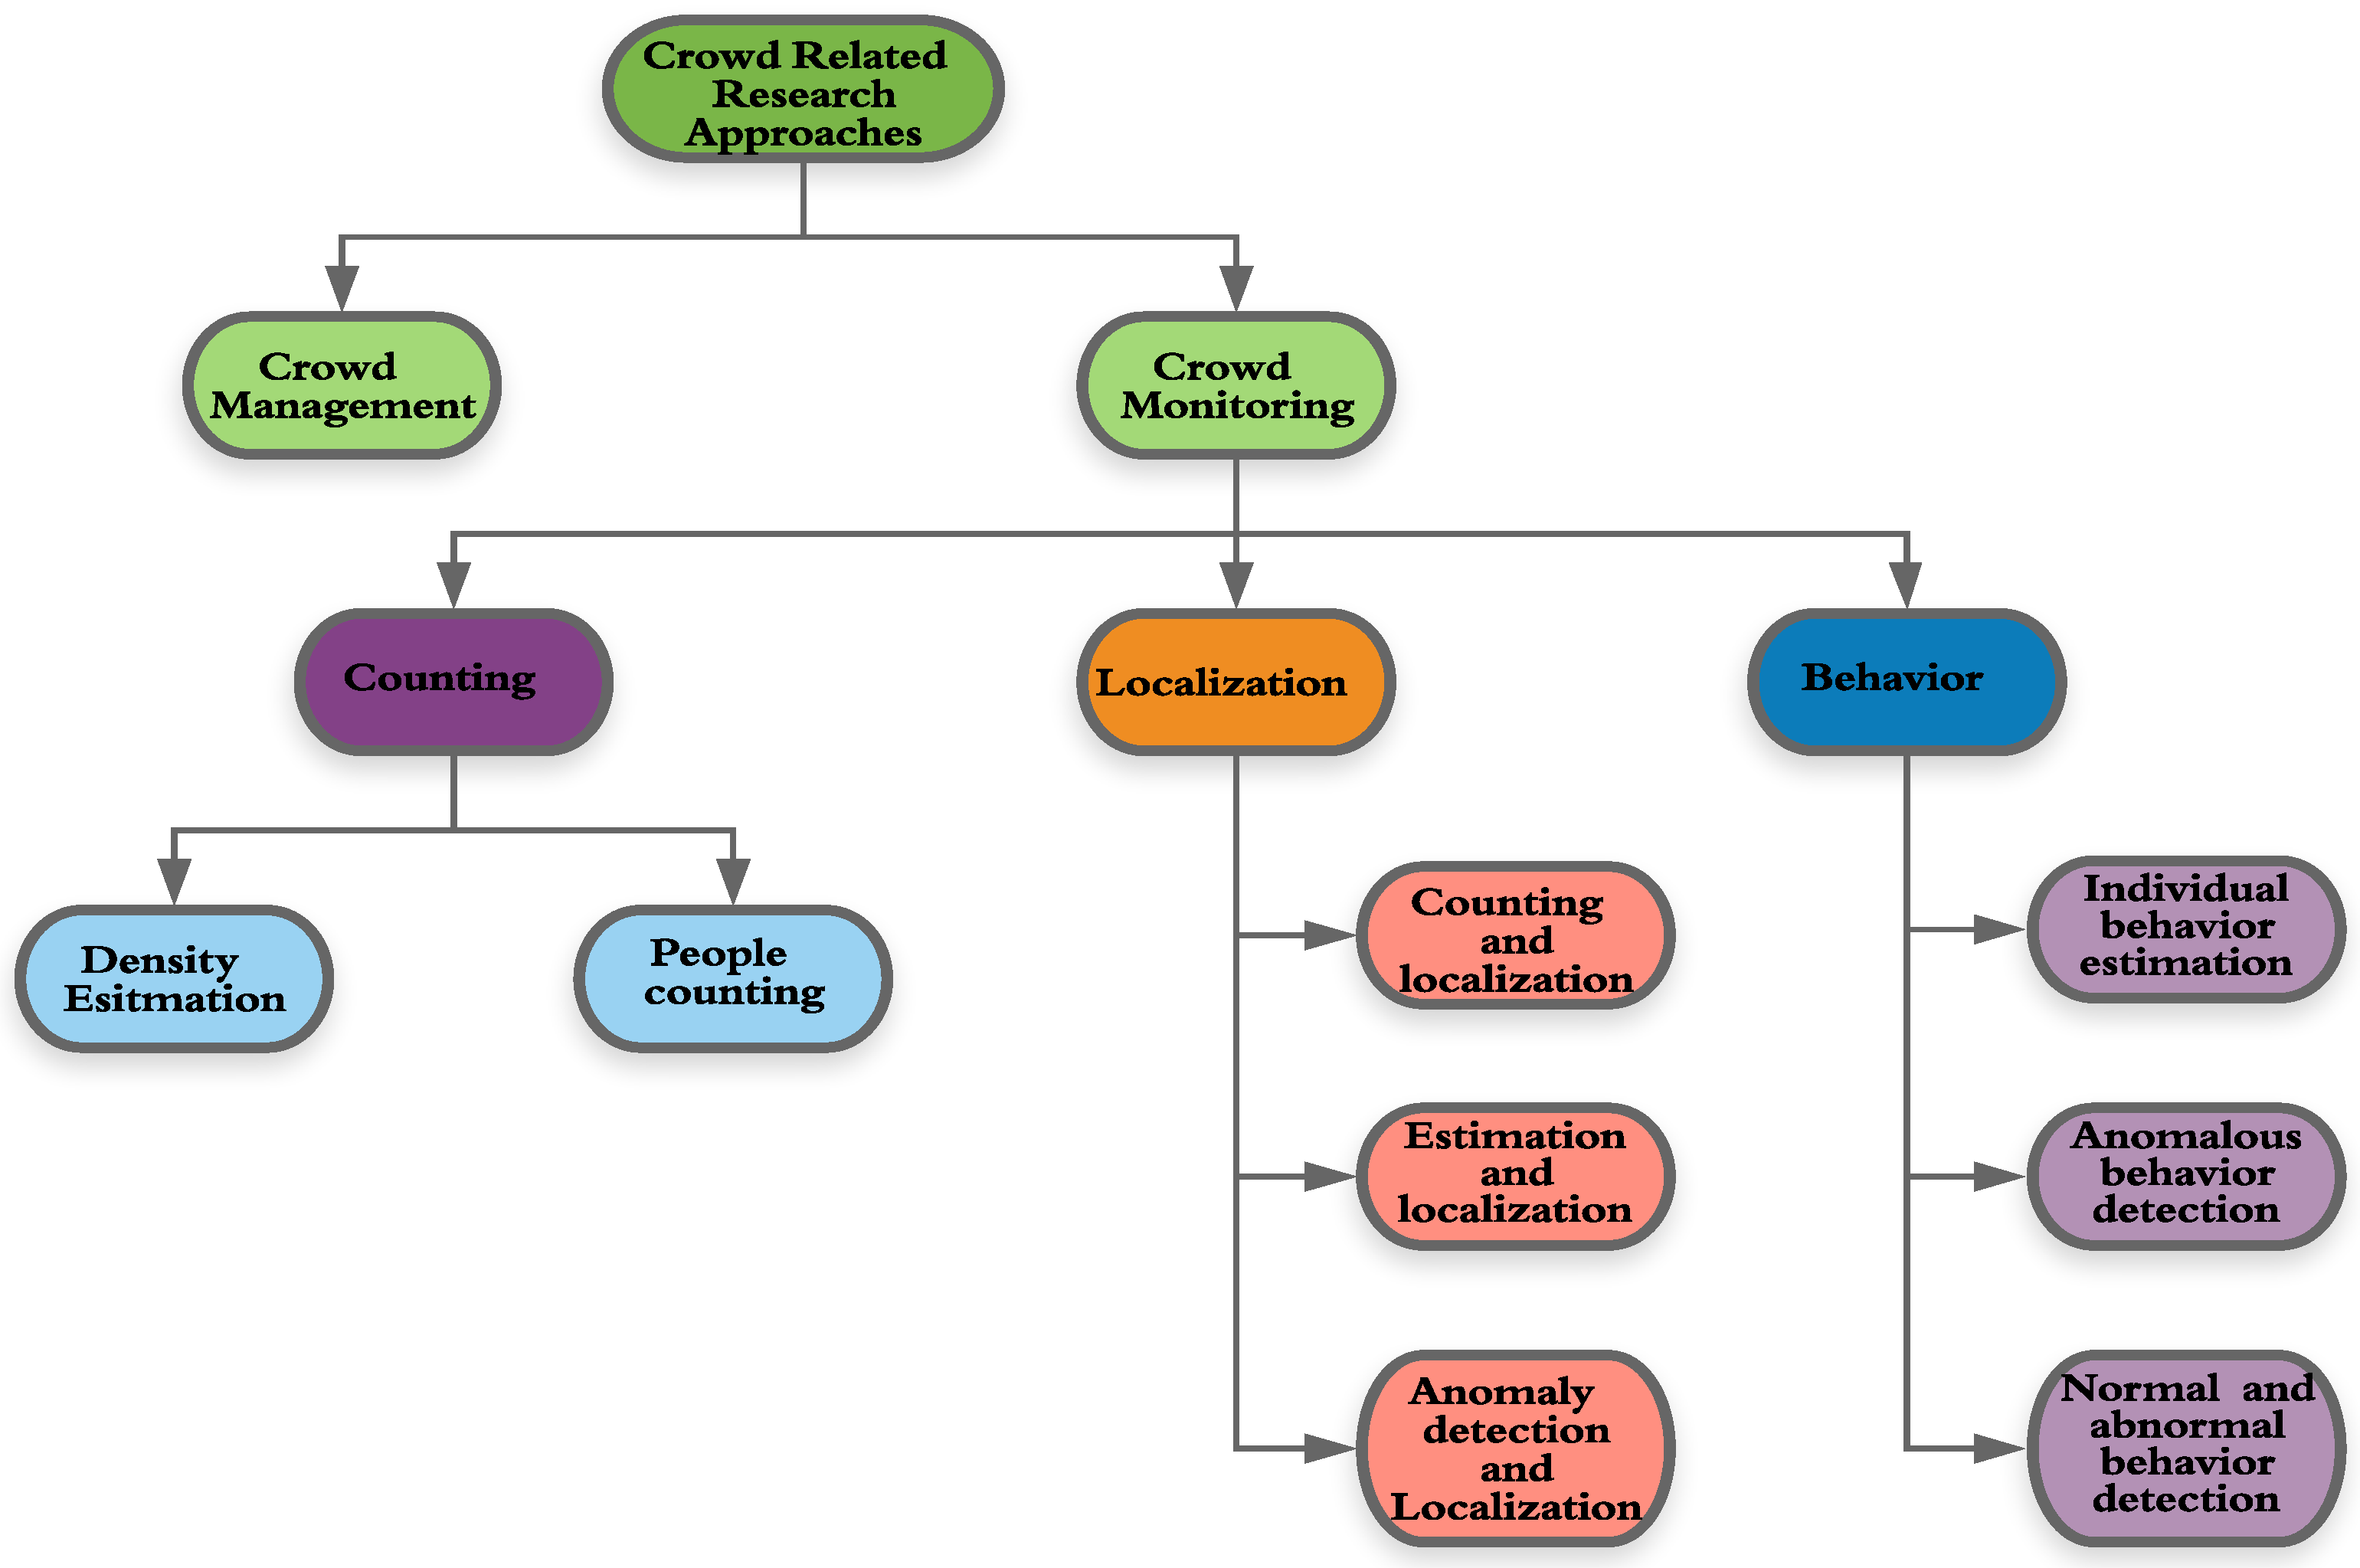

3.2 Development Environment:

The development is done on Windows Operating System using Python modules on Jupiter Notebook. The program was constructed by utilizing Python programming language, which was augmented with Caffe (Convolutional Architecture for Fast Feature Embedding) to optimize its performance. To further refine the program's precision, OpenCV was implemented to conduct image processing and computer vision tasks. During the experiment, a video captured by a smartphone camera was employed to test the functionality of the program, which resulted in valuable insights into its effectiveness.

3.3 Methodology:

The project's primary objective is to develop a comprehensive system capable of detecting and tracking individuals in a given frame. The system achieves this by assigning an object ID to each person detected within the frame and drawing tracking lines to monitor their movements within the frame, including their entry and exit points. Furthermore, the system aims to incorporate the dwell time of each person, which is the duration they spend within the frame, to gain additional insights into their behavior. These features have broad applications, including tracking a person's activity, which can prove advantageous in various settings. Overall, the project's advanced features, which leverage cutting-edge technologies like image processing and computer vision, make it a highly effective tool for enhancing situational awareness, reducing risks, and ensuring safety and security in public spaces.

Implementation and Result

4.1 Modules of Project:

Open CV and Caffe Model are used in the development of model. OpenCV and Caffe are two popular Python libraries used in computer vision and machine learning applications, respectively.
OpenCV is an open-source library that provides a set of tools and functions for performing various image processing and computer vision tasks, such as face detection, object tracking, and image recognition. It is widely used in applications such as robotics, surveillance, and autonomous vehicles.

Caffe, on the other hand, is a deep learning framework that allows developers to train and deploy machine learning models, including Convolutional Neural Networks (CNNs), for various tasks such as image classification, object detection, and segmentation. It is highly optimized for speed and memory efficiency and is widely used in computer vision applications.

In the context of a project that involves detecting and tracking individuals in a given frame, OpenCV can be used for tasks such as object detection, motion detection, and tracking. Meanwhile, Caffe models can be used for tasks such as human pose estimation, face recognition, and gender classification. By combining the power of these two libraries, developers can create highly accurate and efficient computer vision applications that can detect and track individuals with high precision and speed.

4.2 Implementation:

The implementation is done in adherence to the following steps:

Object Detection: The first step is to detect and localize people in the video feed. This is achieved using a pre-trained Caffe model, which can detect people in real-time. The model outputs bounding boxes around the detected people.

Object Tracking: Once people are detected, they are assigned unique IDs that remain constant as long as they remain in the frame. OpenCV's tracking algorithm is used to track people as they move within the frame. Tracking lines are drawn to show the paths of each person.

Crowd Analysis: The system analyzes the crowd behavior to identify patterns in movement and to detect potential threats or hazards. Dwell time of people in the frame is also calculated.

Alerting System: When the system detects potential threats, an alert is generated to notify security personnel. The system can also provide real-time information on crowd density, crowd flow, and crowd behavior.

Overall, implementing a crowd monitoring system using OpenCV and Caffe model in Python can help to ensure the safety and security of people in public spaces by providing real-time information on crowd behavior and detecting potential threats.

4.3 Results and Discussion:

Using person and object detection in crowd monitoring systems can provide a range of valuable results. Firstly, it allows the system to detect and track the movement of individuals within a crowded area, enabling authorities to monitor and manage crowd flow efficiently. Additionally, the system can use person and object detection to identify any suspicious or potentially dangerous behavior, such as unattended objects or abnormal movement patterns, alerting authorities to take prompt action.

Moreover, person and object detection can help prevent accidents, such as slips and falls, by identifying obstacles or hazards in the crowd's path. In addition, the system can use crowd density and movement data to optimize crowd dispersal methods, reducing the risk of overcrowding and associated risks such as stampedes or trampling.

Overall, the use of person and object detection in a crowd monitoring system can improve situational awareness, enhance security, and prevent potential risks and accidents, ensuring the safety of individuals and the smooth operation of crowded events and facilities.

4.4 Month wise plan of word:

Month 1:
- Conduct a literature review of the latest research on person and object detection models.
- Study the different deep learning architectures and identify the most suitable one for the project.
- Gather datasets for training and testing the model and begin preprocessing the data.

Month 2:
- Train the model using the datasets and the selected deep learning architecture.
- Analyze the results of the training and fine-tune the model to improve its performance.
- Evaluate the performance of the model on the test dataset and compare it with existing state-of-the-art models.

Month 3:
- Integrate the trained model with OpenCV and Caffe libraries for implementation in the crowd monitoring system.
- Optimize the model's performance and accuracy for real-time video processing.
- Test the model's performance in different scenarios, such as crowded events or high-traffic areas.

Month 4:
- Refine the model based on feedback from testing and optimize its performance.
- Write the technical documentation for the model, including details of the architecture, dataset, and training methodology.
- Write the user manual for implementing the model in the crowd monitoring system.

Conclusion and Future Plan

- There is potential for the development of more advanced technologies that can provide insights on crowd movement and behavior, enabling more effective crowd dispersal methods.

- For example, the use of sensors and AI algorithms can help to detect and analyze patterns in crowd movement, facilitating real-time decision-making and optimized routing.

- Such technologies can improve the efficacy of flap gates, ensuring that they continue to serve their intended purpose even during peak hours.

References

Research Papers:

- “Gaurav Tripathi, Kuldeep Singh & Dinesh Kumar Vishwakarma” Convolutional neural networks for crowd behaviour analysis: a survey Published: 26 March 2018
- “Ven Jyn Kok, Mei Kuan Lim, Chee Seng Chan” Crowd behavior analysis: A review where physics meets biology Published: 5 February 2016

- Youtube tutorials:
- https://www.youtube.com/playlist?list=PLVgEzPHodXi128SIjFVvlF2XzJEUluDR_
- https://www.youtube.com/watch?v=Vo05vr8fc1U

